

**Customer Retention Case Study**

**Project Report**

Submitted By: OLIVER RAMAN

ACKNOWLEDGEMENT

The following research papers helped me understand the topic Customer Retention:

1.”Pillars of customer retention: An empirical study on the influence of customer satisfaction, customer loyalty, customer profitability on customer retention.”

The aim of this study is to explore relationships among five factors: customer relationship management, customer satisfaction, customer loyalty, customer profitability, and customer retention. The sample of the study consists of 750 managers and employees of different restaurants in Riyadh, the capital city of Saudi Arabia.

2. “Customer Retention -Key to Success for Organization: A Case Study of Banking Industry.”

The study aims to study the customer retention in organization with special reference to banking industry. The results revealed that, to maintain existing customers is becoming more and more important. The reason for this development is based on the knowledge that long term related customers compare various offers against each other and choose the best one. M any reasons are identified as most important reasons for customer defection in a given service industry like banking, but the prominence of each factor depends upon the situation prevailing in each banking organization.

3.”The Antecedent of Customer Satisfaction and Its Impact on Customer Retention in Tourism as Hospitality Industry.”

Taking a case study of tourism as hospitality industry in Lampung Province in Indonesia, we analyze the antecedent of customer satisfaction and its impact on customer retention. Using Structural Equation Model (SEM), we find that customer relationship management has a significant impact on service quality, customer satisfaction and customer retention. Moreover, the impact of service quality on customer satisfaction and the one of customer satisfaction on customer retention are also significant.

INTRODUCTION

Business Problem Framing

Customer satisfaction has emerged as one of the most important factors that guarantee the success of online store; it has been posited as a key stimulant of purchase, repurchase intentions and customer loyalty. A comprehensive review of the literature, theories and models have been carried out to propose the models for customer activation and customer retention.

Five major factors that contributed to the success of an e-commerce store have been identified as: service quality, system quality, information quality, trust and net benefit. The research furthermore investigated the factors that influence the online customers repeat purchase intention. The combination of both utilitarian value and hedonistic values are needed to affect the repeat purchase intention (loyalty) positively.

The data is collected from the Indian online shoppers. Results indicate the e-retail success factors, which are very much critical for customer satisfaction.

· **Conceptual Background of the Domain Problem**

Customer retention refers to a company's ability to turn customers into repeat buyers and prevent them from switching to a competitor. It indicates whether your product and the quality of your service are pleasing to your existing customers.

Customer Retention is the lifeblood of most subscription-based companies and service providers.

The goal is to build a long lasting relationship between the brand and the brands consumers. Customer Loyalty is the main aim of Customer retention. Once a customer is loyal to a particular brand, he/she will not only make repeat purchases but also recommend the brand to others, thereby, increasing sales and increasing the reputation of the brand in the market.

### **Customer retention formula:**

We start by subtracting the number of customers acquired turning the calculation period from your total customer base at the end of the period. Divide that number by the number of customers you had at the start of the period and divide by 100.

Based on high churn rate in some business sectors, customer retention has attracted interest from scholars and practitioners in the field of market research and relationship marketing. The main theme of customer retention is to study the supplier side and their efforts in maintaining good relations with their customers. However, maintaining strong relationships with customers may not be the primary aim of a business, because not all customers and their relationships are profitable. But taking good care of old customers is just as important as gaining more new customers.

The purpose of this project is to understand the importance of customer retention and what role in plays in making a business reputable and profitable. This project investigates the relationship between a business and its customer, the ways in which this relationship can be improved, through customer retention.

· **Review of Literature**

Customer Retention only occurs when a company/business can fulfill the expectations of its customers and also maintain a good long-term relationship with the same customers. Customer Retention is mainly associated with relationship marketing, which gives preference to developing a good rapport with customers with the aim of maintaining them in the long run.

The primary aim of every e-retailer is to attract a prospective customer to his e-tail site. This requires significant resources in terms of the ad spend. Ad spends have grown so large that as much as two-thirds of the capital raised by online companies go towards advertising.

C. W. Chang & Zhang (2016) found that an offline (retail-store) channel can be used to migrate customers from an inactive state to an active state, effectively serving the purpose of education or revival, whereas an online channel is most effective in keeping the existing active customers active, thus serving the purpose of retention.

Vogel & Paul (2015) show that channel-based price differentiation positively affects customers through perceived value but harms retention through price unfairness and limited self-determination.

Ruiz Díaz (2017) found that in mobile phone market customer satisfaction influences strongly on customer loyalty, and in turn Loyalty is an important determinant of customer retention.

Customers’ retention intentions will be higher when they start using a service with a free monthly fee promotion rather than when they start it with a free joining fee promotion (J. Kim, 2019).

Service quality and personalized attention is the most important factor followed by high cost of repair and time taken in servicing, according to industry experts, but from the customer's point of view, service quality and personalized attention are the most important factors, followed by time taken in servicing and workshop timing (Kumar, 2017).

Osakwe & Anaza (2018) reveal the use of both traditional and digital marketing resources is associated with higher organizational performance, and customer retention efforts implemented by a firm, along with brand promotional tactics, increase not only firm profitability but also customer loyalty.

Service value (i.e., convenient hours, quality, friendliness), as well as length of ownership influence service retention, also, gender moderates the service value dimensions and service retention relationships such that various components of service value (convenient hours, friendliness and quality) were significant predictors of service retention whereas service value (friendliness, quality) were significant predictors of service retention for females (Darley & Luethge, 2019).

The retail sector plays a major part when checking customer churn or retention. The Retail Sector is dependent on many factors that drive the sales of a company and one of these major factors is customer retention. Social Media and Advanced Technology also play a major role in affecting the customer retention of a business/company.

This study is based on various factors from the customer side and how these factors increase customer retention.

· **Motivation for the Problem Undertaken**

This is my first project in which i had to conduct Data Visualization. In this project i got to conduct Univariate and Bivariate Analysis of the data provided. I was happy to use the various data visualization techniques which i learnt to visually analyze the data. Also, after using these techniques, i was better able to understand the dataset thereby, helping me find a way for customer retention.

ANALYTICAL PROBLEM FRAMING

Mathematical/Analytical Modeling of the Problem

The Customer Retention Dataset that was provided for the study, contained 269 rows and 71 columns. There were a total of 269 respondents who were asked about 71 questions in a survey about the satisfaction, trust, and their commitment towards an online retailer. Two datasets were provided in a zipped folder.

First, the datasets were downloaded from the zipped folder. Then, they were filtered to check for any duplicate values or any null values. The number of columns and rows were checked, the data types of each column was also checked. It was found that the dataset contained 70 categorical columns and 1 numerical column. All the columns were individually analyzed using count plots and pie charts. After visualizing the columns, we found some interesting insights into the buying patterns, payment patterns, internet usage etc. of the respondents.

Data Sources & their formats

The data in the dataset is collected from our respondents who are Indian Online Shoppers. From the results we see that the success of e-retailers depend on various factors which in turn affect customer retention.

There were 2 sheets of data that was provided of the case study. One was Detailed which had the detailed responses provided by the respondents, & Encoded which was the response of the respondents in binary format for easy interpretation.

We could use either one of the sheets for our study. I chose the detailed sheet.

Snapshot of the data:

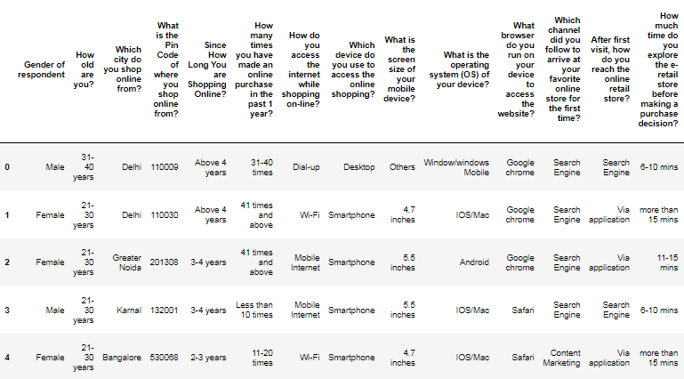

The following columns were present in the dataset:

‘Gender of respondent',

'How old are you? ',

'Which city do you shop online from?'

'What is the Pin Code of where you shop online from?'

'Since How Long You are Shopping Online?',

'How many times you have made an online purchase in the past 1 year?'

'How do you access the internet while shopping on-line?'

'Which device do you use to access the online shopping?'

'What is the screen size of your mobile device?'

'What is the operating system (OS) of your device?'

'What browser do you run on your device to access the website?'

'Which channel did you follow to arrive at your favorite online store for the first time?'

'After first visit, how do you reach the online retail store?'

'How much time do you explore the e- retail store before making a purchase decision?'

'What is your preferred payment Option?'

'How frequently do you abandon (selecting an items and leaving without making payment) your shopping cart?'

'Why did you abandon the “Bag”, “Shopping Cart”?'

'The content on the website must be easy to read and understand.'

'Information on similar product to the one highlighted is important for product comparison.'

'Complete information on listed seller and product being offered is important for purchase decision.'

'All relevant information on listed products must be stated clearly.'

'Ease of navigation in website.'

'Loading and processing speed.'

'User friendly Interface of the website.'

'Convenient Payment methods.'

'Trust that the online retail store will fulfill its part of the transaction at the stipulated time.'

'Empathy (readiness to assist with queries) towards the customers.'

'Being able to guarantee the privacy of the customer.'

'Responsiveness, availability of several communication channels (email, online rep, twitter, phone etc.)',

'Online shopping gives monetary benefit and discounts.'

'Enjoyment is derived from shopping online.'

'Shopping online is convenient and flexible.'

'Return and replacement policy of the e-retailer is important for purchase decision.'

'Gaining access to loyalty programs is a benefit of shopping online.'

'Displaying quality Information on the website improves satisfaction of customers.'

'User derive satisfaction while shopping on a good quality website or application.'

'Net Benefit derived from shopping online can lead to user’s satisfaction.'

'User satisfaction cannot exist without trust.'

'Offering a wide variety of listed product in several category.'

'Provision of complete and relevant product information.'

'Monetary savings.'

'The Convenience of patronizing the online retailer.'

'Shopping on the website gives you the sense of adventure.'

'Shopping on your preferred e-retailer enhances your social status.'

'You feel gratification shopping on your favorite e-retailer.'

'Shopping on the website helps you fulfill certain roles.'

'Getting value for money spent.'

'From the following, tick any (or all) of the online retailers you have shopped from:'

'Easy to use website or application.'

'Visual appealing web-page layout.'

'Wild variety of product on offer.'

'Complete, relevant description information of products.'

'Fast loading website speed of website and application.'

'Reliability of the website or application.'

'Quickness to complete purchase.'

'Availability of several payment options.', 'Speedy order delivery.'

'Privacy of customers’ information.'

'Security of customer financial information.'

'Perceived Trustworthiness.'

'Presence of online assistance through multi-channel.'

'Longer time to get logged in (promotion, sales period).'

'Longer time in displaying graphics and photos (promotion, sales period).'

'Late declaration of price (promotion, sales period).'

'Longer page loading time (promotion, sales period).'

'Limited mode of payment on most products (promotion, sales period).'

'Longer delivery period.', 'Change in website/Application design.'

'Frequent disruption when moving from one page to another.'

'Website is as efficient as before.'

'Which of the Indian online retailer would you recommend to a friend?’

The data set has 269 rows and 71 columns.

Data preprocessing done

The data set was import onto the jupyter notebook because it was in an excel sheet. Next, all the basic analysis such as head (10), tail (10), shape, nunique, value counts of each column present in the dataset. In the excel sheet I noticed some duplicate values in the column ‘'How do you access the internet while shopping on-line?'’, so I made changes in the excel sheet before importing it in the jupyter notebook.

Then I checked if the data frame contained any null values or missing values using .is null ().sum (). No null values or missing values were found in the dataset. Then, I checked the number of categorical (discrete) columns and the number of numerical columns. The dataset contained 70 categorical columns and 1 numerical column.

Hardware and Software Requirements & Tools used

HARDWARE REQUIRED:

Processor -> Intel Core 5 and above

RAM -> 6GB

SSD -> 250 GB and above

SOFTWARE REQUIRED:

Anaconda

Jupyter Notebook

LIBRARIES USED:

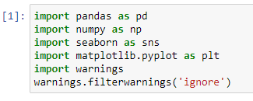

DATA ANALYSIS & VISUALIZATION

Graphs and Diagrams

Since all the features are categorical in nature we use count plot and pie charts to get a better understanding of these features in univariate analysis.

Here are some of the plots we visualized on the jupyter notebook.

:

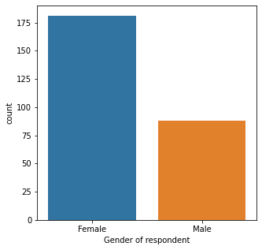

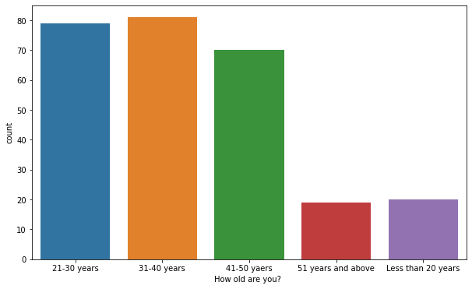

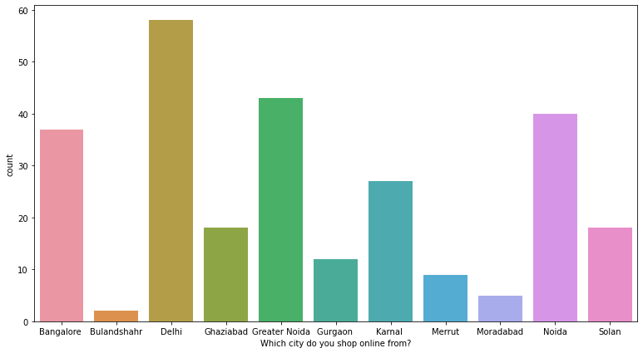

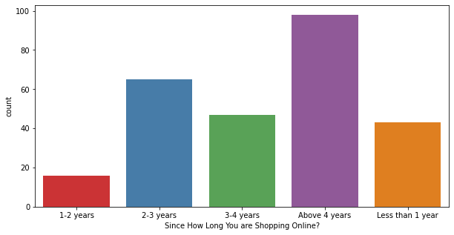

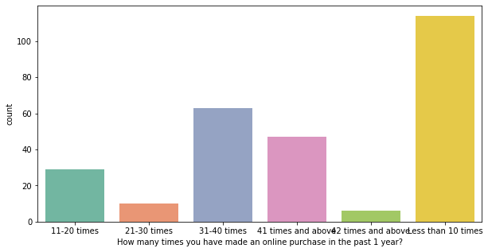

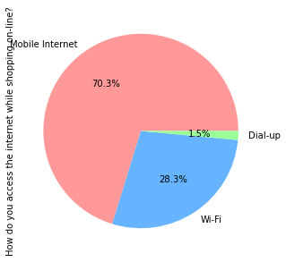

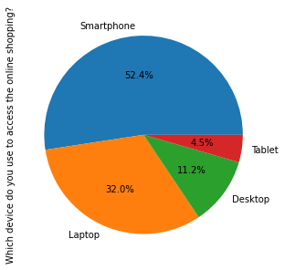

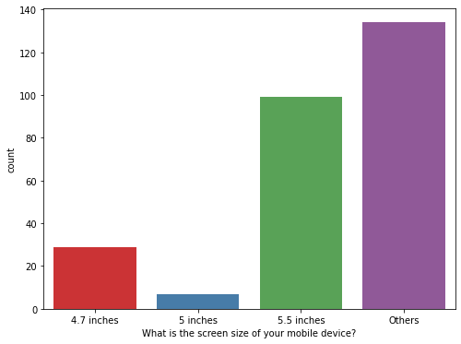

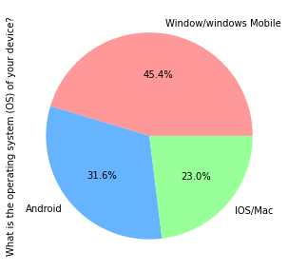

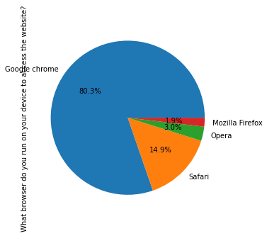

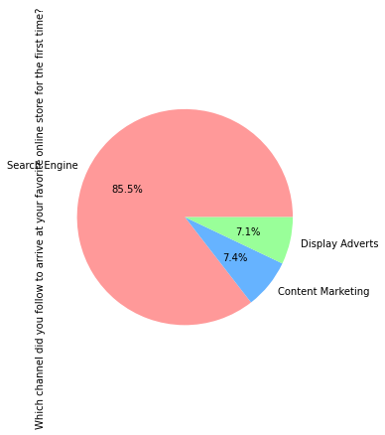

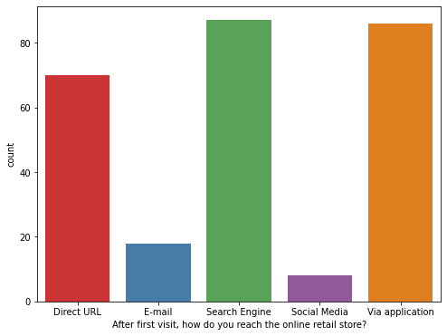

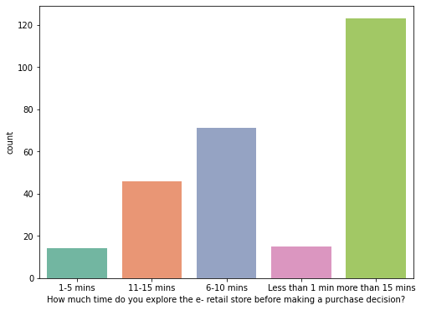

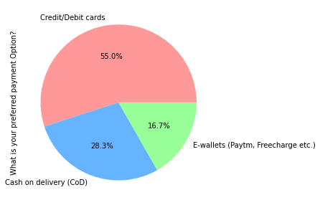

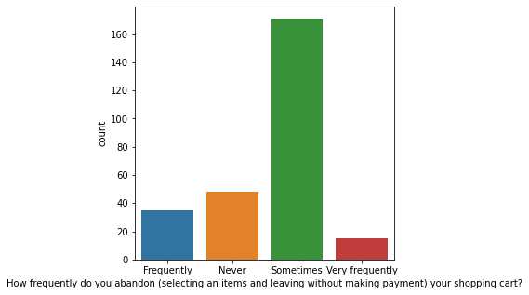

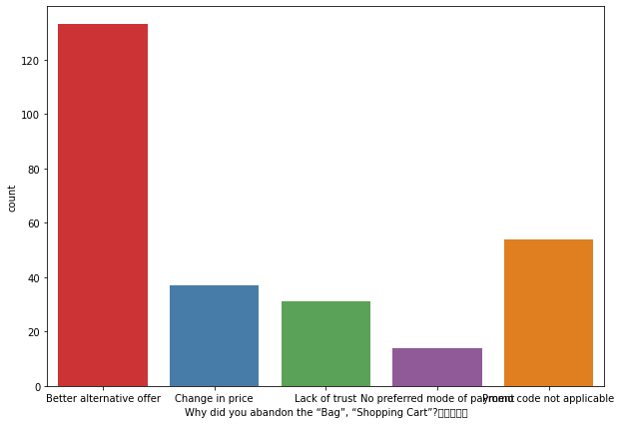

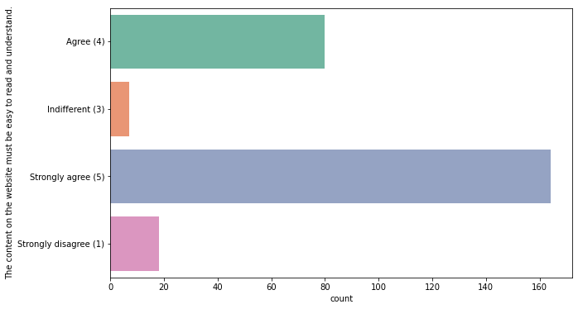

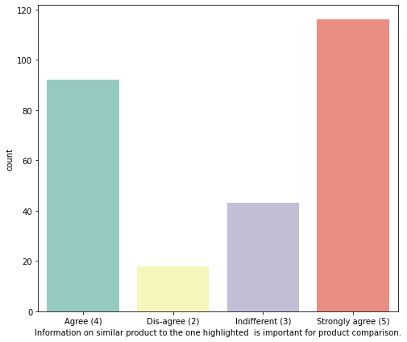

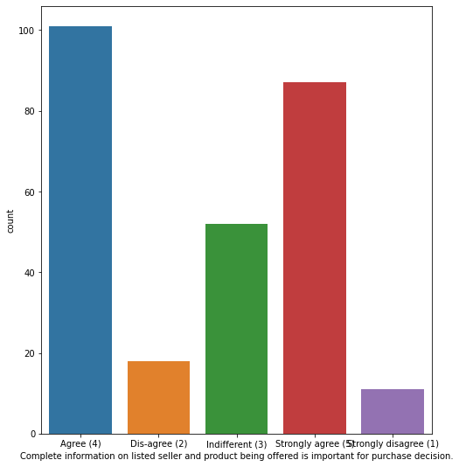

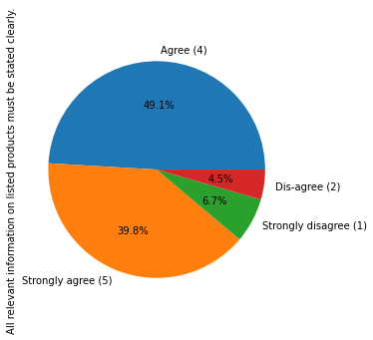

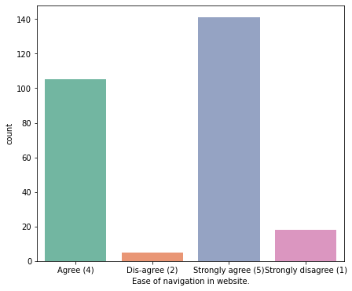

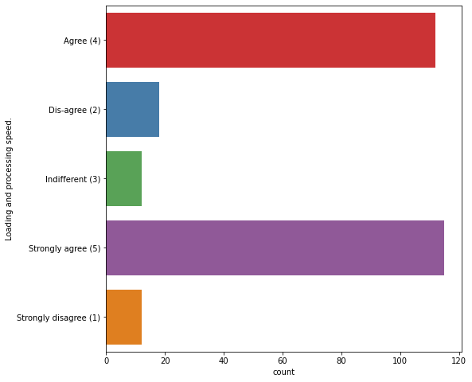

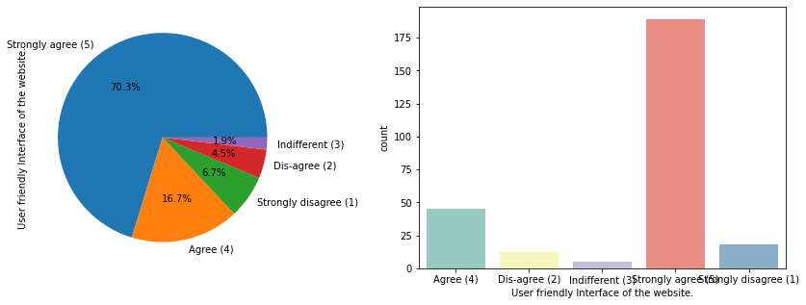

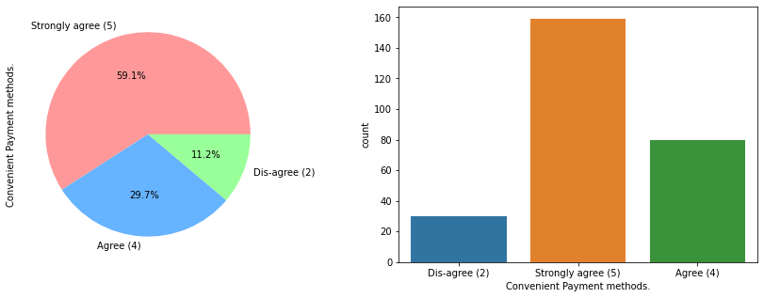

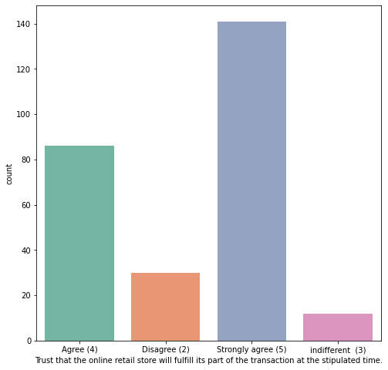

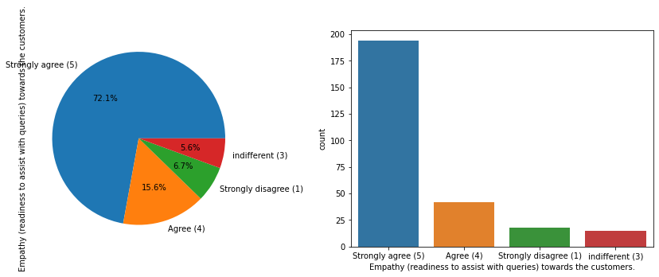

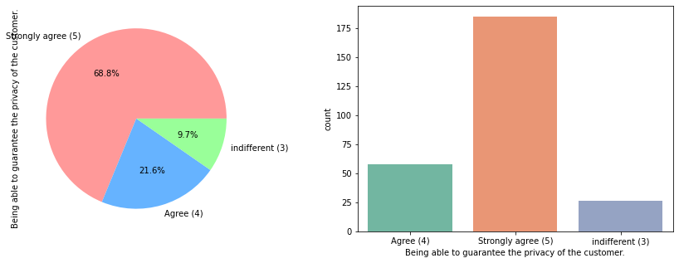

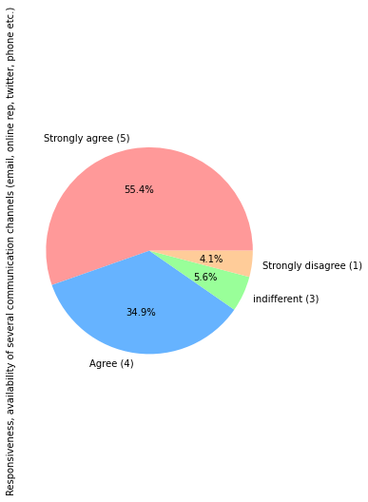

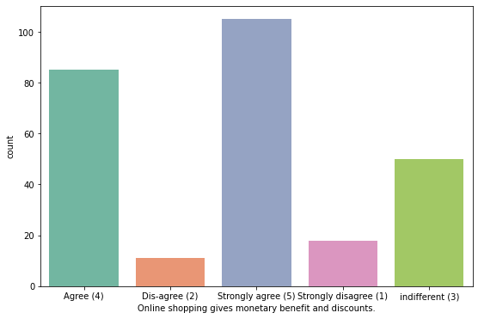

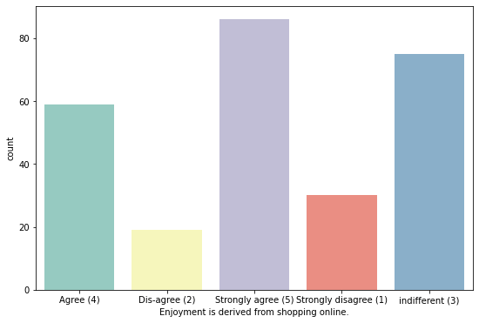

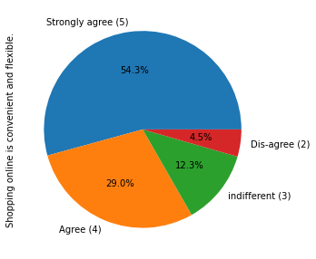

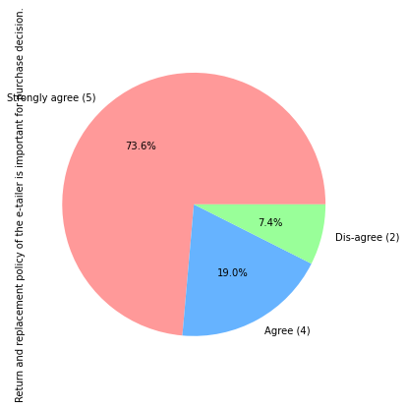

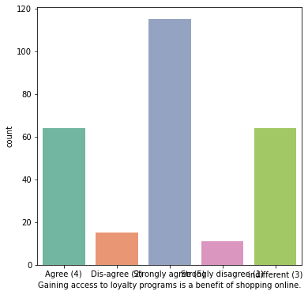

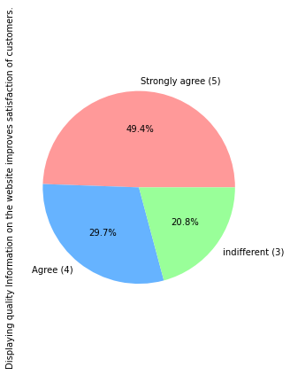

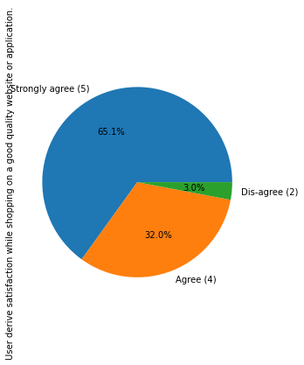

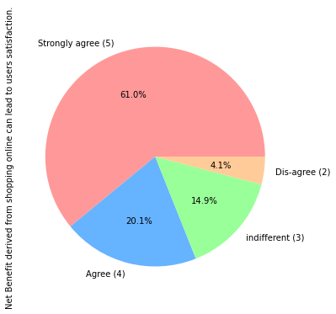

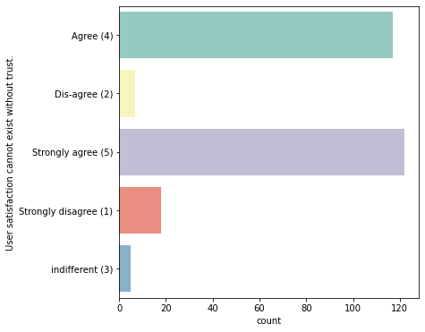

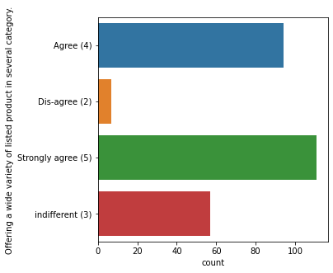

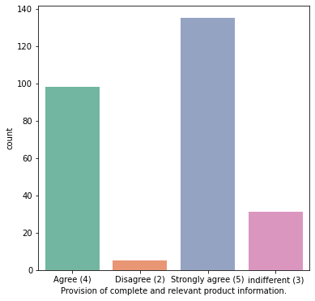

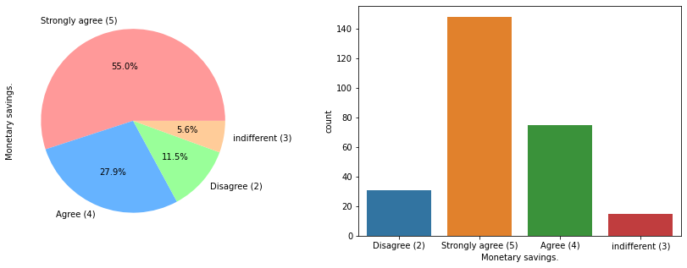

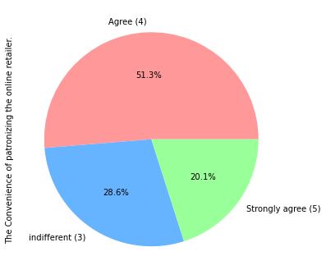

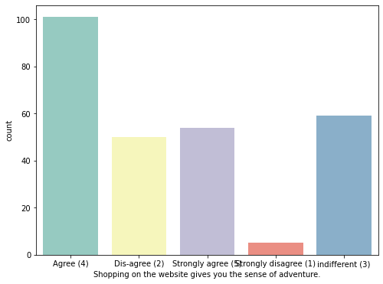

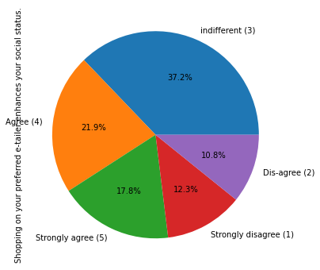

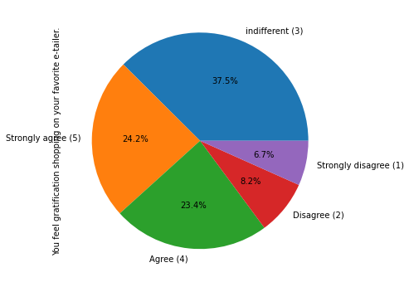

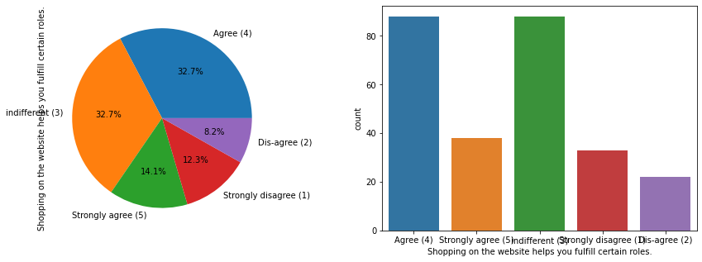

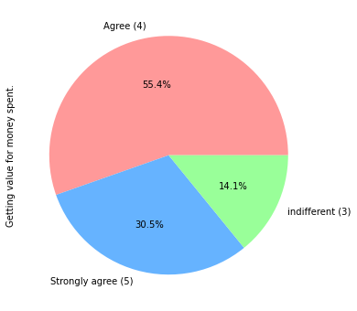

Results

After Plotting all the graphs for each column in the jupyter notebook, and plotting more graphs for bivariate analysis we got the following results:

1. Most of the customers are females belonging to the age group 20-50 years of age.Also most of the respondents are from Delhi, followed by Greater Noida and Noida.
2. Most of our respondents use Mobile Internet to access the online retail store. Also, they have a shopping experience of 4 + years and usually buy less than 10 items a month
3. Most of our respondents have WIndows as their operating system.
4. The main way to get into the online shopping platform for first timers was through search engines. After that the respondents oce again preferred to visit the online shopping platform through search engines.
5. The preferred mode of payment for our respondents is through DEBIT/CREDIT cards.
6. Most of our respondents agree and strongly agree that the content of the website must be easily to read, similar product information of related products must be provided by the online retail store, there must be clarity regarding the Product Information and the Seller’s Information.
7. The respondents also agree that the website of the online shopping retailer or e-retailer must have a user friendly interface, good loading and processing speed, easy navigation & convenient payment methods.
8. The respondents also agree that the online shopping retailer must have customer empathy, must guarantee the customer’s privacy, must give timely fulfillment of orders, must be trustworthy, must provide various channels for filing responses.
9. Respondents also expect the online shopping platform to have a goood returns & replacement policy, the quality of the website must be satisfactory, customers must be provided with benefits and discounts, and access to loyalty programs.
10. They also agree to providing User trust, Products in several categories, Relevant product information, satisfaction in quality information, Net Benefit Satisfaction & Monetary Savings derived from shopping online.
11. The respondents also agree that shopping online gives them a sense of adventure, helps enhance their social status, gives them a sense of gratification, gives them a feeling of Role Fulfillment and gives them their Money’s worth.
12. Compared to other online shopping platforms, AMAZON.IN and FLIPKART.COM are most heard of and have many benefits rather than drawbacks.
13. On the other hand, PAYTM.COM, MYNTRA.COM & SNAPDEAL.COM have may drawbacks and are less frequently used than other the online shopping platforms.

CONCLUSION

From the results we can conclude that,

There is high customer retention in:

Amazon.in

Flipkart.com

There is a high risk of customer churn in:

Myntra.com

Snapdeal.com

Paytm.com

When customers are satisfied with a company or service, there is a high possibility that they will share their experience with other people (other customers) and recommend the services of said company. Therefore, it is very important for E-commerce retailers to take into account the customer satisfaction because this will help retain customer loyalty as well as attract new potential customers. All this leads to an increase in sales, which is the main goal of any company/business.